First steps Instruction
Connection:
- Connect 5V to device, using AC adapter or powerbank, the 12V power supply is also acceptable, but not recommended. 12V the maximum voltage
- Check you phone, find for ecologicXXXX device
- Connect to it, use password “12345678”
- The phone will ask you about “remain connection”, answer “yes”
- On your phone go to 192.168.4.1 address
- Open WIFI settings, then choose your WIFI network, click save
- Now we need to find your device IP address, use your router, or go to site ecologic.go.ro and find for IP address
- Open your device IP address
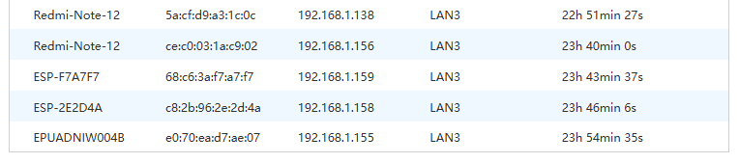
Main Page
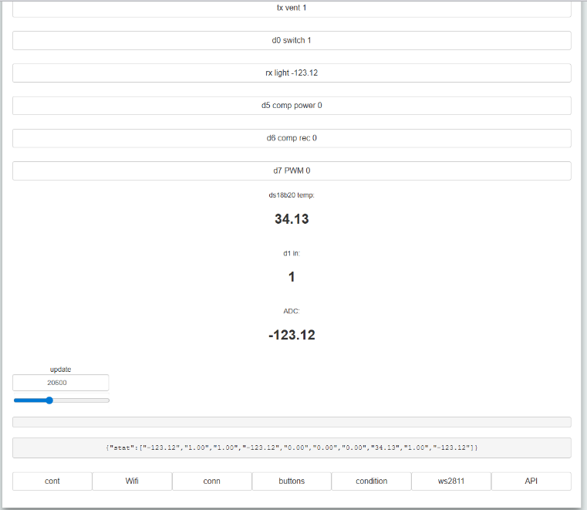
You can switch relays, or use different power for DC, also you can see temperature and humidity
WIFI page
Choose your WIFI settings, it is recommended to choose Client mode,
Client mode – your device working in WIFI client mode
AP mode – your device will be discoverable via WIFI
Clint+AP – both modes together

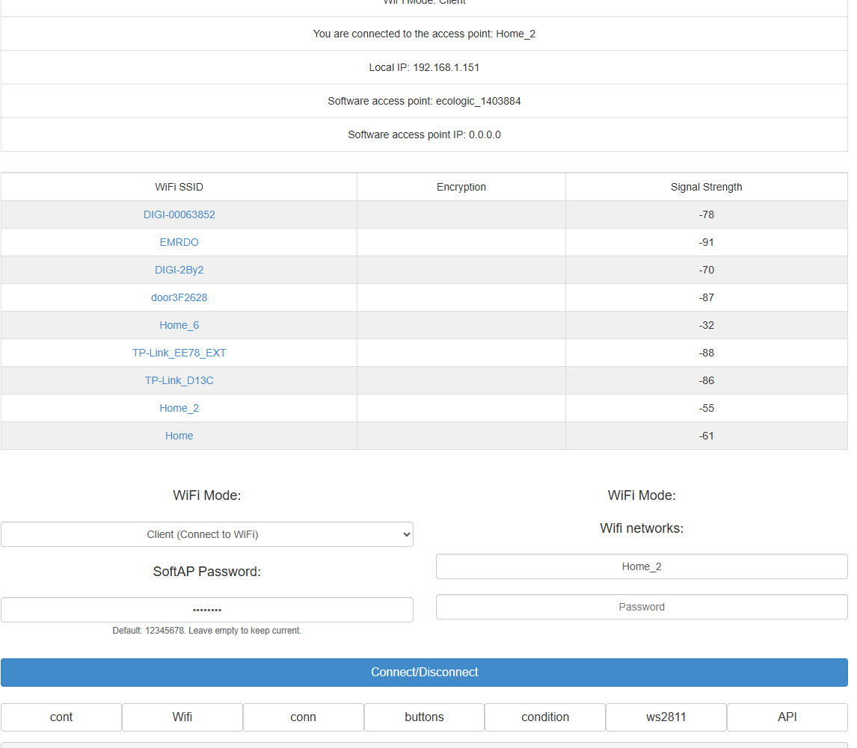

Choose your WIFI settings, it is recommended to choose Client mode,
Client mode – your device working in WIFI client mode
AP mode – your device will be discoverable via WIFI
Clint+AP – both modes together

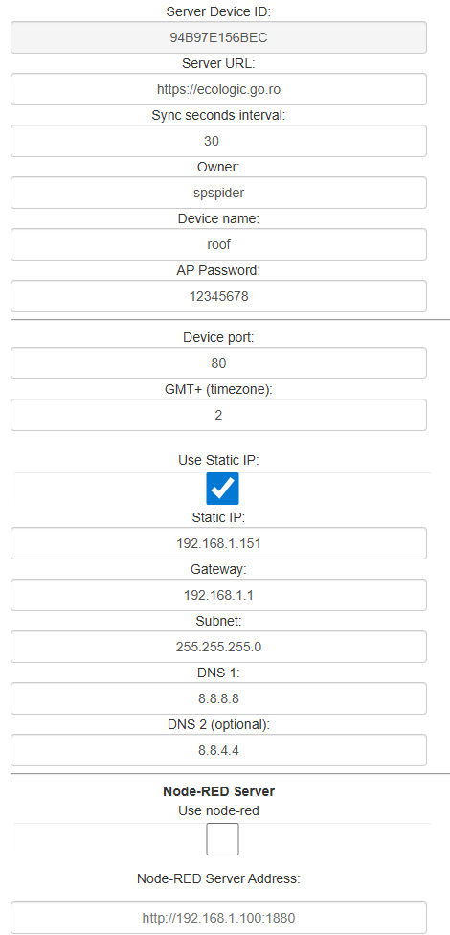
Server URL – needed for device, to connect to API server, don’t change it
Sync interval – how often the device will check updates from server, it is recommended not less then 5 seconds
Owner – if you want to sell device, change for a new name of owner
Device name – use short device name
AP password – password for first connection
Port – how you can reach your device ex: 192.168.1.151:80
Use static IP – it is recommended to use static IP, to do not change it after you rooter reboots

Node-red Server – you can configure the hook events by this node-red server

